


Conference Programme

2nd International Islamic Tourism Conference
Halal Tourism, Religious Tourism, Heritage and Cultural Tradition

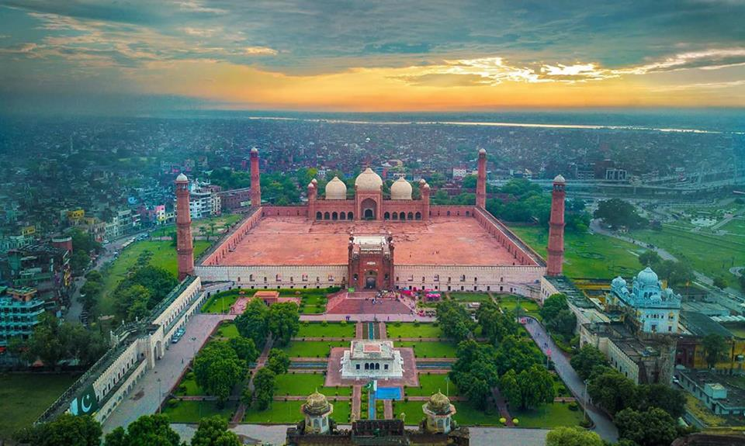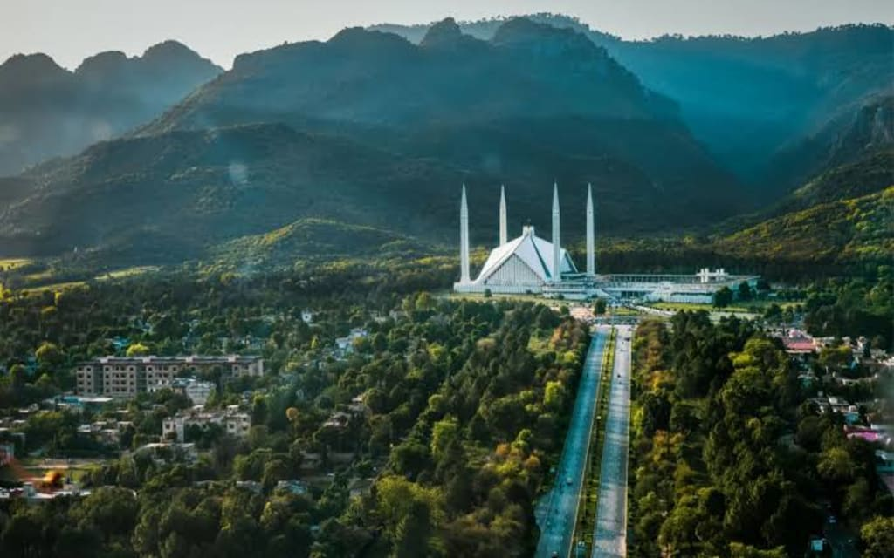
Faisal Mosque Islamabad
Badshahi Mosque Lahore

Lahore Leads University, Lahore, Pakistan
16th- 19th September 2026

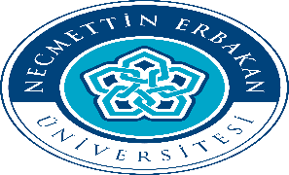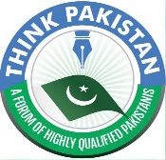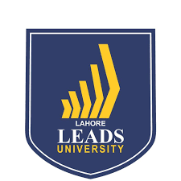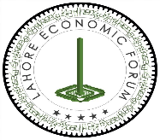

Opening Session

Day 1 Thursday September 17, 2026
 | 09.00 -09.30 |  | Registration  Lahore Leads University  Kamahan Road, Near DHA Phase V, Lahore, Pakistan.
 | 09.30 -09.50 |  | Opening of Ceremony  Guests to be Seated at 9:30 am  Tilawat: 9:40 am  National Anthem: 9:45 am
 | 09.50 -09.55 |  | Conference Opening: Dr. Abdus Sattar Abbasi
 | 09:55  10:05 |  | Welcome Address: 9: 50 am Professor. Dr. M. Nadeem Bhatti (VC LLU)
 | 10.05 -10.10 |  | Introduction of Conference: Professor. Dr. Ahmad Albattat, Jordan
 | 10.10- 10.35 |  | Keynote Speech: Professor. Dr. Kashif Hussain, APU University, Malaysia  Topic: Halal Tourism as an Economic Engine: Global Trends, Strategic Frameworks,  and Market Opportunities
 | 10.35 - 10.40 |  | Consulate General of Kazakhstan, Mr. Rao Khalid Mustafa Khan
 | 10:40 -  10:50 |  | Prof. Dr. Uzma Qureshi, VC (LCW University)
 | 10:50 – 11:00 |  | Guest of Honour: Mr. Hafeez Ullah Niazi, President TV Today
 | 11.00 - 11.15 |  | Chief Guest: Mr. Saleem Haider Khan, Governor of Punjab
 | 11.15 - 11.25 |  | Presidential Address: Mr. Zahoor Ahmad Wattoo  Chairman, Lahore Leads University
 | 11.25 -11.35 |  | Vote of Thanks: Professor. Dr. Ishtiaq Ahmad Gondal, (PVC, LLU)
 | 11.35 -11.45 |  | Souvenir Presentation and Group Photo:
 | 11.45 -12.15 |  | Networking Tea/ Coffee
 | 12.15 -12.45 |  | Keynote Speech: Professor. Dr. Yasin Bilim, Necmettin Erbakan University, Turkiya  Topic: Let’s ask to AI “Which countries would you recommend for Islamic tourism?”  Chair: Professor. Professor. Dr. Ishtiaq Ahmad Gondal, (PVC, LLU)
 | 12.45- 14.00 |  | Networking and Lunch

Session Two
Programme for Paper Presentations
Thursday 17 September 2026
14.00 – 15.30 Paper Presentations Session 1
Chair: Dr. Jamil Anwar – COMSATS University Islamabad Abbottabad Campus
Paper Title | Author(s)
Sustainable Halal Tourism and Islamic Heritage Preservation: A Strategic Framework for Cultural Identity and Economic Development in Muslim Countries | Iqra Sialkot & Hafiz Mohsin Zia Qazi
Analysis of Non-Muslim Tourists’ Perspective on the Mosque Tour Experience at the Tourism Mosques in Malaysia. | Maimunah Binti Abdul Aziz, Siti Salwa Safari & Tengku Elvirozita Tengku Mansor
Beyond the Destination: Representing Islamic Heritage as a Catalyst for Sustainable Halal Tourism | Abdul Rehman Sajid
Pakistan's Readiness for the Global Halal Tourism Market: Opportunities, Challenges, and Policy Recommendations | Abu Zafar Sadiq
Building Trust in Halal Tourism: Governance Frameworks for Certification, Inclusion and Sustainability | Muhammad Abubakar
15.30 – 15.45 Tea / Coffee
15.45 – 17.15 Paper Presentations Session 2
Chair: Razaq Raj – Leeds Beckett University, UK
Paper Title | Author(s)
Enhancing the Muslim Traveler Experience: A Shariah-Compliant AI App to fulfill their religious requirements | Hassan Usmani
Emerging Motivations of Halal Tourists: Trends, Drivers and  Implications For Sustainable Global Tourism | Tayyaba Razzaq
Purpose-Oriented Tourism in Islam: Reframing Travel Beyond Leisure and Consumption | Muhammad Imran Mirza
Evaluating Halal Service Quality and Its Influence on Hotel Pricing Strategies | Ahmad Albattat
Islamic Identity in Hotel Design and Operations: A Conceptual Framework | Mohammad Alam

Friday 18 September 2026
09.30 – 10.30: Invited Speakers Session

Chair: Professor. Dr. Yasin Bilim

Professor. Dr. Shin Yasuda, Takasaki City University of Economics
Topic : Rethinking Islamic Tourism through Ta‘awun (Mutual Cooperation): Sociability and Community
Development for Muslim Societies

Professor. Dr. Razaq Raj, Leeds Beckett University, UK
Topic : International Perspectives on Safeguarding Cultural and Religious Heritage Sites

Professor. Dr. Ahmed Jamal, Cardiff University, UK
Topic : Rediscovering Islamic Civilisation : The Role of Islamic Heritage in Shaping Muslim Tourists'
Identity and Travel Intentions

10.30 – 11.30 Expert Discussion Panel

Chair: Professor. Dr. Ahmad Albattat
Topic: Islamic Tourism: A Potential Segment for Pakistan’s Economy

Dr. Shin Yasuda - Takasaki City University of Economics, Japan
Dr. Adeel Anjum - Director Meezab Group
Dr. Abeera Babur - Tourism Development Corporation Punjab
Dr. Muhammad Kamran - Head Department of Tourism University of Punjab
Khalid Usman - Member of Lahore Chamber of Commerce
Najmus Saqib - Director General, PWCA
11.30 – 11.45 Tea / Coffee

11. 45 – 12.45 Paper Presentations Session 3
Chair: Dr. Muhammad Kamran – University of Punjab
Paper Title | Author(s)
Islamic Faith with AI: An Artificial Intelligence Based Halal Travel Supporting Model for Muslim Tourists Globally | Hamza Khalid Ibn-e-Battuta
Muses from Past: Personal Memory of Collective Heritage | Urooj Waheed
AI-Driven Statistical Analysis of the Saudi Arabian Tourism Market During Hajj and Umrah Seasons | Anum Ali & Noreen Aamir
Building Resilient Halal Tourism Ecosystems through  Integrated Risk Management Approaches | Munir Hussain & Huzaifa Shabbir
12.45 – 14.00 Networking Lunch / Friday Pray

14.00 – 15.00 Paper Presentations Session 4
Chair: Dr. Kashif Hussain – APU Malaysia
Paper Title | Author(s)
Exploring the Role of Internet of Things (IoT) in Enhancing Sustainable Performance: A Case Study of the Hotel Industry in Pakistan | Muhammad Faisal Majeed & Amer Hussain
Beyond the Plate: Expanding Halal Certification to Full-Spectrum Islamic Tourism and Hospitality | Salman Saeed, Khurram Shahzad, Yasar Saleem, Abdul Ahid & Shaista Nawaz
Fading Signals: The Declining Digital Footprint of Sufi Shrine Urs Commemorations in Pakistan. Evidence from Google Trends | Rafi Amir-ud-Din, Abdus Sattar Abbasi & Abdul Wahid
Sustainable Halal Tourism: Integrating Islamic Principles with Responsible and Eco-Friendly Travel | Muhammad Sarwar
Faith-Informed Sustainability: Perspectives of Indonesian Muslim Tourists | Hera Oktadiana

15.00 – 16.00 Paper Presentations Session 5
Chair: Dr. Shin Yasuda – Japan
Paper Title
Interfaith Heritage and Islamic Tourism: Reinterpreting Mughal-Jain Sacred Landscapes in South Asia | Sidrah Shoaib
Religious Tourism: The Role of Islamic Movement Parties — A Case Study of Jamaat-e-Islami Pakistan (JIP) | Jamil Anwar & Abdus Sattar Abbasi
Preserving the Sacred: The Contribution and Representation of Islamic Heritage in Global Halal Tourism | Hafiz Muhammad Ammar
A Comparative Study of the Memoirs "Lahore: A Sentimental Journey" and "Istanbul: Memories and the City": The Significance of Melancholic Inflection in Celebrating Culture | Aiman Amjad, Mahmood Ahmad Azhar, & Faisal Majeed
16.00 – 16.15 Tea / Coffee

16.15 – 17.30 Paper Presentations Session 6
Chair: Dr. Ahmad Jamal – Cardiff University, UK
Paper Title | Author(s)
Blockchain Technology as a Framework for Authenticating, Protecting, and Monetizing Islamic Cultural Heritage: Challenges and Opportunities | Zafar Iqbal & Qaisar Bilal
From Monuments to Metadata: Reconstructing Pakistan’s Legal Framework for Technology-Enabled Heritage Conservation through Comparative Lessons from Japan | Muhammad Imran Ali
Environmental Sustainability Challenges in Abbottabad: Assessing the Impact of Tourism on Urbanization | Sultan Mahmood
Trust in Treatment: Governance and Accreditation Frameworks for Halal Medical Tourism | Muhammad Abubakar

17.30 – 18.00 Closing Ceremony
Closing Address: Mr. Hamza Zahoor Wattoo, President Lahore Leads University and
Professor. Dr. Ishtiaq Ahmad Gondal, (PVC, LLU)
Abdus Sattar Abbasi, Yasin Bilim, Ahmad Albattat, Razaq Raj

19.30 Gala Dinner

19.09.2026 Saturday
Field Trip

